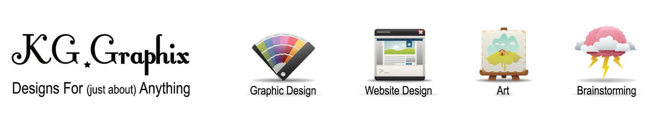

Club Mac Google Intro .:. April 2011
About Google Products
Google is ever expanding, an experiment in what is the most useful tools and methods in today’s technology world. In just the recent months, Google has unleashed Google Voice inside Gmail for free phone calls through the computer, Priority Inbox which learns what emails mean the most to you to better prioritize them, the functionality to remove Gmail’s conversation thread view, the ability to access two Google accounts at one time for multi tasking, and announced Google TV for making your TV time an even richer experience. No matter what your profession or computer skill level, Google most likely makes a product to fit. The goal of this presentation will be to take your pre-submitted questions to inform you of the products and/or releases you want to know about as well as try to help everyone get the most out of their Google experience!
Please visit the online form to submit your question for the presentation!
https://spreadsheets.google.com/viewform?hl=en&formkey=dFdNVHZ5YmlyaEEwUkxLbS1UYXNMZnc 6MA#gid=0
About Krystlyn Giedt
Krystlyn Giedt is the owner, graphic designer, and website developer for KG Graphix. KG Graphix helps businesses and individuals take their ideas, wants and needs, and transform them onto paper and web. I'm here to help because that’s what I love to do! Please visit my website at http://www.kggraphix.comor email me at k.giedt@gmail.com for more information!

